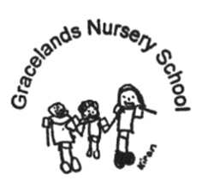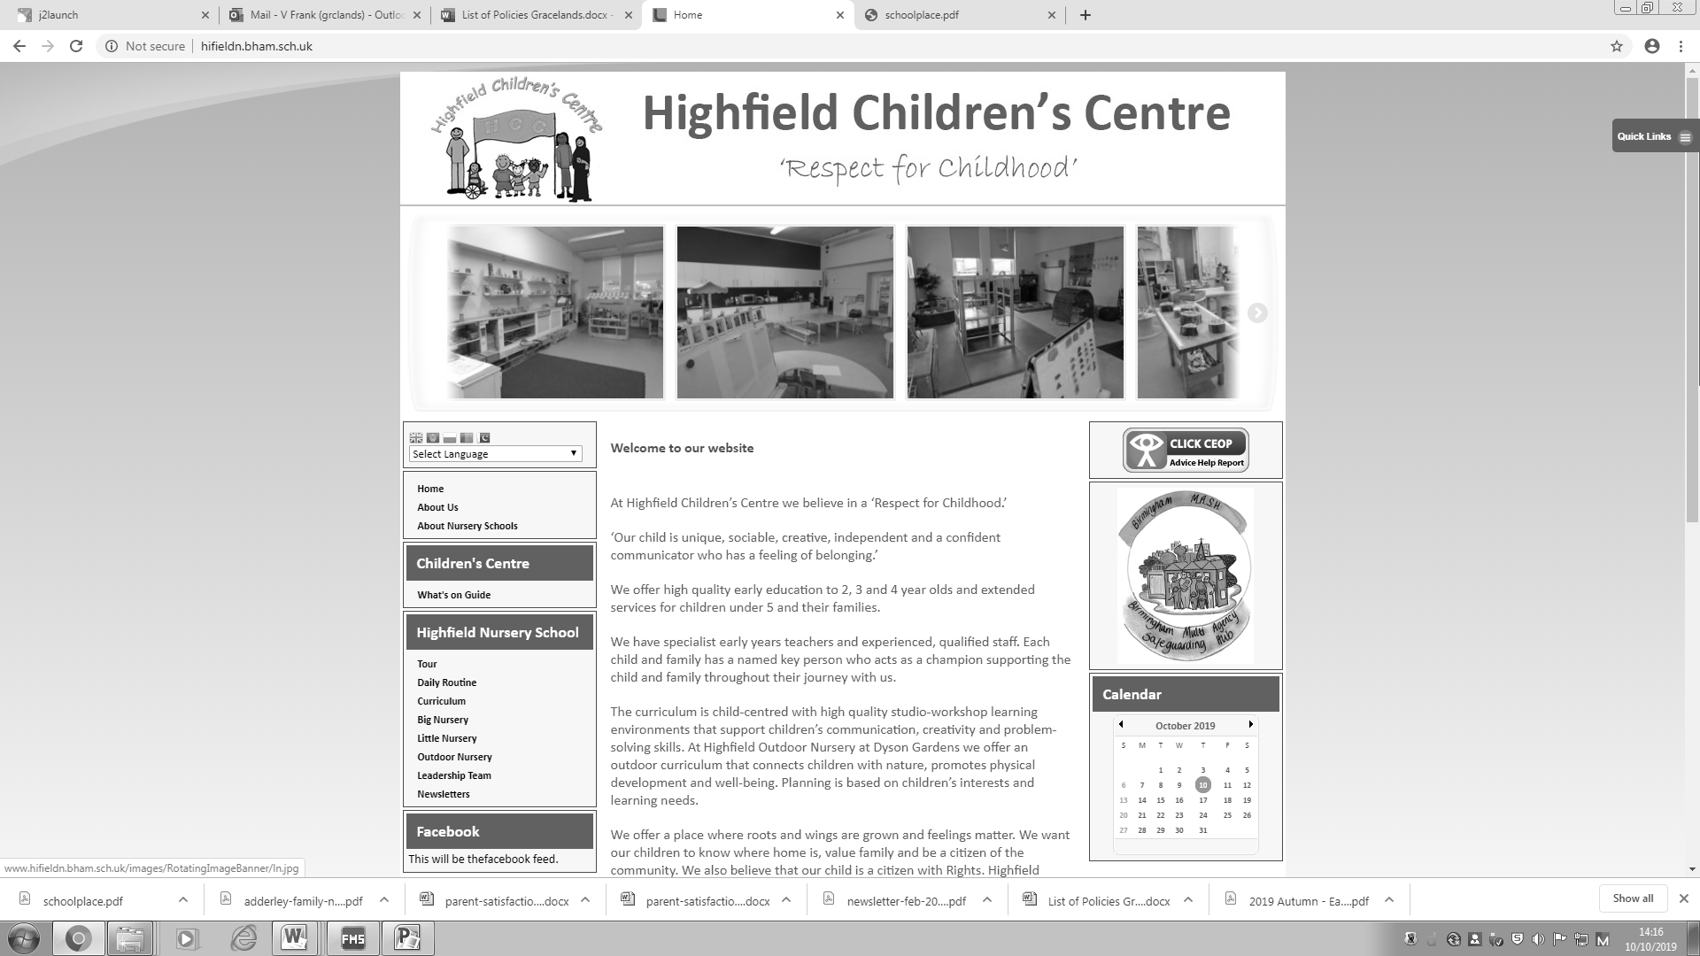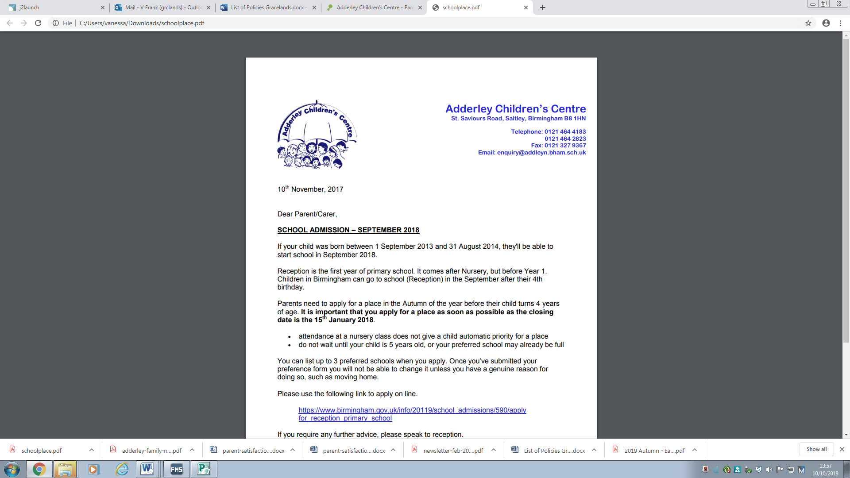

**British Values Statement**

* At Adderley, Highfield and Gracelands Nursery Schools we follow:

The policies and procedures from Birmingham City Council and Birmingham Safeguarding Children Board (BSCB) which includes the government's prevent strategy.

**British Values Statement**

**British Values** United Nations Convention on the Rights of the Child - Article 14

At Adderley, Highfield and Gracelands Nursery Schools we value all of our children and families. We celebrate our rich cultural and religious diversity and promote mutual respect. We are an inclusive setting and our ethos and curriculum enables children to be independent learners-making choices and building strong relationships particularly with their peers. We encourage this by structuring the environment and timetable to enable individual, paired, small and large group activity. We have certain rules that children and adults must follow for example; have kind hands, say kind words and mobile phones only in designated areas. This enables a safe learning environment. All of these form our framework for promoting British values-democracy, the rule of law, individual liberty, mutual respect and tolerance of those of different faith and beliefs

**Rights Respecting School**

This statement is in accordance with the 1989 United Nations Convention on the Rights of the Child (UNCRC)

**Article 7 -** Every child has the right to a legal name and nationality, as well as the right to know and, as far as possible, to be cared for by their parents.

**Article 8 -** Governments must respect and protect every child’s right to an identity and prevent their name, nationality or family relationships from being changed unlawfully. If a child has been denied part of their identity illegally, governments must act quickly to protect and assist the child to re-establish their identity.

**Article 14 -** Every child has the right to think and believe what they want and also to practise their religion, as long as they are not stopping other people from enjoying their rights. Governments must respect the rights of parents to give their children information about this right.

**Article 29 -** Education must develop every child’s personality, talents and abilities to the full. It must encourage the child’s respect for human rights, as well as respect for their parents, their own and other cultures, and the environment.

**Article 30 -** Every child has the right to learn and use the language, customs and religion of their family, whether or not these are shared by the majority of the people in the country where they live.

**Article 41 -** If the laws of a particular country protect children better than the articles of the Convention, then those laws must stay in place.

